Once the Invoices are signed and entered into A/P print an Open Payables Listing. Decide what cheques are to be printed based on what Payables are due now and/or in the near future.

Pull all those invoices and put them in order, make sure you have all invoices that need to be paid.

Once you have all your invoices ready, go into adagio and begin creating cheques.

**Adagio- Payables**

Cheques

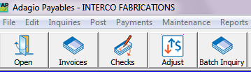

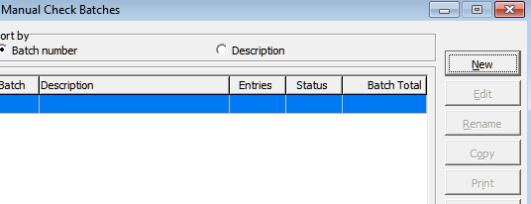

Enter Vendor Code, Make sure Print Cheque is selected and select the invoice #s that you are paying from that list. Confirm that you have selected all the invoices you want to pay and only those and then select OK.

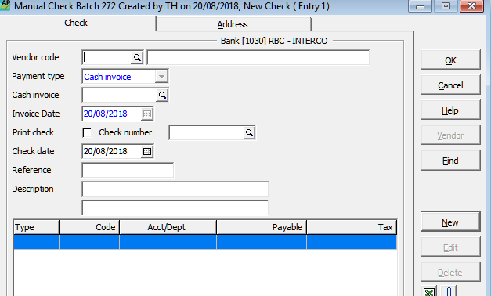

Repeat this process as often as necessary until you have all your cheques created.

Go back to your batches window and select Print

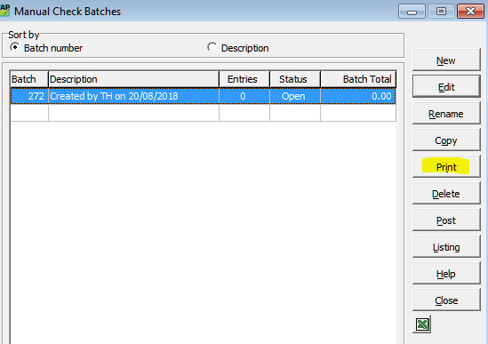

The specification is “Interco New Cheque”

Then select

-Setup

-Properties-Print Black only